|  |  |
| --- | --- |
| A sunset over a body of water with a city in the background  Description automatically generated  nyc Airbnb  An analysis to determine the best predictor variables of NYC Airbnb prices. | Jaclyn Coate, Laura Lazarescou, Reagan Meagher  MSDS 6372 Applied Statistics: Project 1 |

Table of Contents

1. Introduction 21

2. Data description 21

3. Exploratory data analysis (EDA) 22

4. Objective 1: inuitive multilinear regression model 24

A. Problem Statement 24

B. Model 24

C. Comparing Models 24

We worked on comparing a different models using intuitiveness and multiple automatic selection methodologies offered through software packages such as: forward, backward, seqrep. We well as, LASSO/LARS. The strength of these different models can be seen below in our adjusted r2. 24

The final model we went with is our intuitive model and you can follow the analysis below. 24

i. Intuitive: Figure XX for code and model output in R 24

Using automatic selection methods with the below models we chose to include interaction terms between all of the continuous independent variables. After logical reduction of variables in our EDA we were left with fewer variables then preferred when doing selection methods. With the addition of the interaction terms of the continuous independent variables then we are adding complexity to our models that would help with a better prediction. 24

ii. Forward: Figure XX for code and model output in R 24

iii. Backward: Figure XX for code and model output in R 24

iv. Seqrep: Figure XX for code and model output in R 24

Based on our above adjusted r2 chart we can conclude that the strongest model is formed by our intuitive model. We acknowledge the adjusted r2 for our intuitive model may be larger than those others shown, however it is still not as strong as we would like. This again supports the possible conclusion that a multiple linear regression model may not be the best fit for our data. 24

v. LASSO: Figure XX for code and model output in R 25

vi. Adj R2 Chart between tried models (Figure XX) 25

D. Assumptions: Intuitive 25

i. Residuals 25

ii. Constant Variance 25

iii. Independence 25

iv. Multicollinearity 25

v. Outliers: Leverage / Cook’s D 25

E. Cross Validation 25

F. Interpretation: Intuitive Model 25

Interpretation REQUIRED 25

What variables could be collected and included in the future to make a better model? (Note from meeting with Turner) 25

Confidence Intervals REQUIRED 25

Multiple linear regression is just one option in building a predictive model for a continuous response. In our analysis we are see that a MLR analysis was likely not the best way to create our prediction model. We found it difficult to surface any linearity between the independent continuous variables and the dependent continuous variable. We saw shapes in Figure 1 through Figure 4 that likely demonstrate a more complex relationship than just linear. Any sort of extreme transformation actually results in the data moving farther away from linearity. 25

Since we surfaced the above facts about out data and our data is large, we think that other methods such as Random Forest of K-NN would perform better. These options are less time consuming because the models’ complexity is built into software algorithms. We would also not have to specify how a relationship exists ahead of time, like we have for MLR. 25

This being state we have seen a strong relationship between the borrow of the city as well as the room type being rented. This leads us into a Two-Way Analysis of Variance (ANOVA) model as it meets all the requirements to use this unique method (Figure 9). In our next section we explore what we surface with our Two-Way ANOVA. 25

~~Notes from meeting with Turner~~ 25

~~Unit 2 slides – building blocks slide – add interactions slide~~ 25

5. Objective 2: two-way analysis of variance 25

A. Problem Statement & Methodology 25

We analyzed the ability to predict the prices of Airbnb listings in NYC based on the variables provided per unit by Airbnb. We completed a full exploratory data analysis (EDA) and took into account practicality of the information we determined the two best factors to determine the price were: *neighbourhood_group, and room_type* (reference code in Figure 10). 26

Note: We chose to use *neighbourhood_group* instead of *neighbourbood* (used in MLR). This is due to the interaction’s significance and the ability to report back that information in a digestible way. 26

B. Analysis 26

i. Two Factor, Two-Way Analysis of Variance (ANOVA) 26

With our two-way ANOVA, we were in a two independent categorical variables scenario. With our cleaned data we created a summary containing: *mean, standard deviation, standard error, minimum, maximum, and inner quartile range* of our dependent variable: *price* (reference code in Figure 10). 26

ii. Mean Profile Plotting 26

Once this was completed, we used the table to create a mean profile plot (Figure 11). We determined our Two-Way ANOVA was displaying nonadditive model characteristics; in other words, our graph, Figure 11, indicated that the changes in the mean price of an Airbnb in a specific neighborhood depends on what type of room you are renting. 26

Our data set had an unequal number of observations between groups in the independent variable: *room_type*, this means our data is unbalanced. Therefore, the means plot we have displayed is using the standard deviation instead of our standard errors from the summary table. This is because the plot using standard deviations allows us to gain better insight into the assumptions of equal variance. This is because the standard error is not a measure of variability of the data itself. 26

iii. Diagnostics 26

With the above results we can fit a full nonadditive model (Figure XX). Overall, we can see the residual show close to an even distribution, Figure XX (left graph). We identified a near random cloud of residuals around the 0 x-axis. There is a slight unevenness in the difference of distribution, however we move forward with the assumption met as this is close to normality and while a logged transformation may bring it closer to a random cloud, it is also not perfect (Figure XX). Allowing to the model to stay in a linear and unlogged format makes for practical interpretation and analysis. 26

There is a small concern for the violation of normality. In Figure 12 (right graph), we can see that the data is slightly skewed right. There is tail reaching to the right side of the histogram, however the majority of the data is distributed around zero. In reviewing this further we can see the same results in our QQ plot, Figure 12 (middle graph), while we would prefer a perfectly straight line, this is close with only a we would expect to see this as close to a straight line as possible. We moved forward with the assumption passed after invoking the Central Limit Theorem due to the large sample size and move forward with this slight departure from normality. 26

There are no extreme outliers present in our Cooks D / Leverage graph (Figure XX). All of the points on the far right still fall below our dashed line and also fall well below our level of leverage of 1. 27

Lastly, to address the independence assumption, it is important to note that New York City is a place of expensive real estate. The borrows (neighborhoods) contained within the city contribute to how expensive real estate may or may not be. This would in sense, seem to violate our assumption of independence, since we are saying the neighborhood a house is in would often determine the price and therefore likely the rental price. But since all real estate is going to be dependent on the real estate around it, all modeling for pricing would have to have assumed independence Therefore, we move forward cautiously with the assumption of independence met. 27

iv. Testing 27

For our testing we performed a high-level ANOVA that tested to see if the individual metrics, as well as their interaction show a significant p-value at the 0.05 alpha level. To do this we completed a Type-III Sums of Squares F-test; our results show that both our independent metrics *neighbourhood_group,* *room_type*, as well as our interaction between them *neighbourhood_group* room_type* are overwhelmingly statistically significant at the alpha 0.05 level. The F-values and p-values are: [622.677, <.0001]; [98.739, <.0001], and [20.121, <.0001] respectively (Figure XX). Since the interaction term is significant at the 0.05 alpha level, we have confirmed our assumption that this model is nonadditive and reject our H0, determining solidifying that the neighbourhood depends on room type (and vice versa) when it comes to predicting price of an Airbnb in NYC. 27

Since our interactions have proven significant, we moved forward with Tukey-Kramer (since all assumptions have been met in our model) pairwise comparisons of every variation of the *neighbourhood_group* and *room_type* variables paired. This will tell us which pairs of the *neighbourhood_group* and*,* *room_type* are significant since the Type III SS test only tells us that they are significant in general. 27

Examining the adjusted p-values and confidence intervals, there are multiple comparisons that yields overwhelmingly statistically significant results with p-values < 0.05 alpha level (at a 95% confidence level). These comparisons can be found in Figure 16. There are so many groups we recommend referencing the plot found in Figure 17, any confidence internal shown that does not cross the zero threshold is showing a statistically significant p-value at the 0.05 alpha level. All non-significant pairs have been called out in Figure 18. 27

C. Interpretation 28

When we ask ourselves how much something is going to cost, we often research those similar items on our own to have an educated guess on the amount of money we are going to spend. We have done just this with our two-way ANOVA for NYC Airbnb customers. In this analysis we used two categorical variables to predict the dependent variable: price of an Airbnb in NYC based on neighborhood and type of rental. Our immediate conclusions tell us yes, with over whelming statistical evidence, the price of your Airbnb will be determined by neighborhood and the type of rental you choose. Out of 105 comparisons 69 were deemed statistically significant in our pairwise comparison of the different neighborhoods and room types with p-values <= 0.01 which is less than the alpha level of 0.05 (Figure 17). 28

Differently stated, the practical significant in taking into account the borrow and room type you rent will highly affect the amount of money you spend on your Airbnb in NYC. For example, in Figure XX we have ordered the difference in price mean from lowest to highest. This is showing us that the difference in money you can save by renting a shared room in the Bronx as compared to an entire home/apt in Manhattan can be upwards of 147.56 dollars a night! This is huge saving when you want to spend more money on your experiences and not where you might be storing your luggage for a trip. Overall, you can see that any shared room in a neighborhood other than Manhattan is showing us a great saving in dollars spent. I would note that if a shared room is something you can handle; this is how you would save the most money when renting and Airbnb in NYC. Secondly, you can see that shared and private rooms in any neighborhood other than Manhattan are showing a significant difference in mean price of the Airbnb. This means that in general, if you want to save money while staying at an Airbnb in NYC, you might want to consider staying outside of the city center and commuting into Manhattan for all your tourist needs. 28

~~i.~~ ~~Notes from meeting with Turner~~ 28

~~ii.~~ ~~There’s so much sample size that everything is significant.~~ 28

~~iii.~~ ~~**Practical Significance~~ 28

6. Appendix 30

A. Figure 1 30

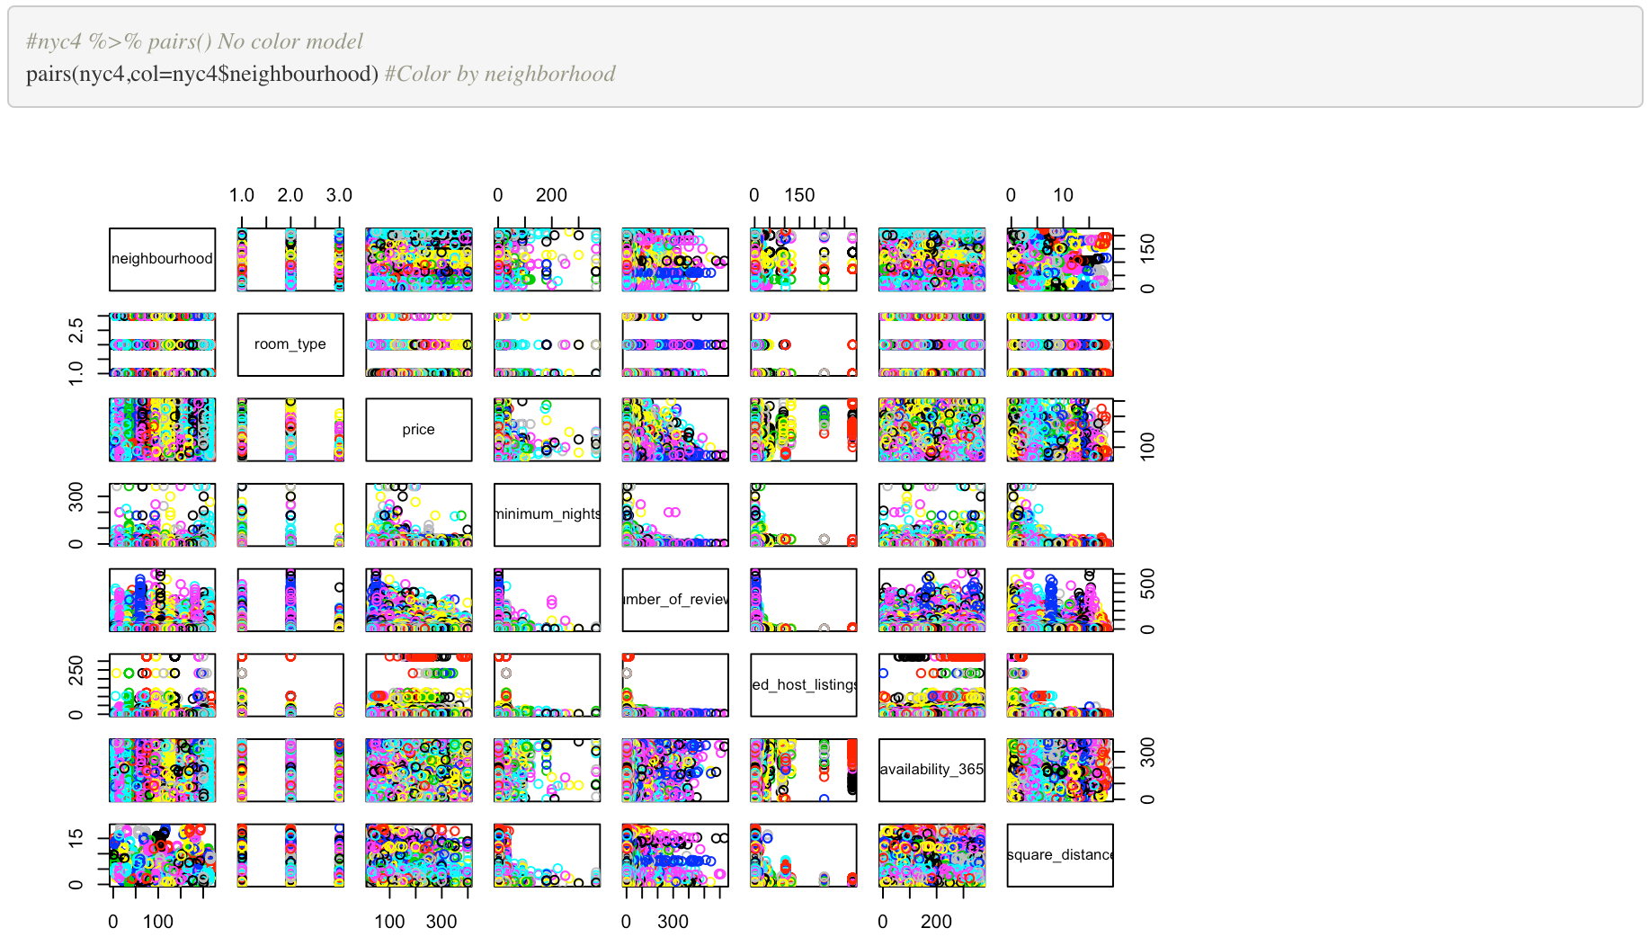 30

B. Figure 2 30

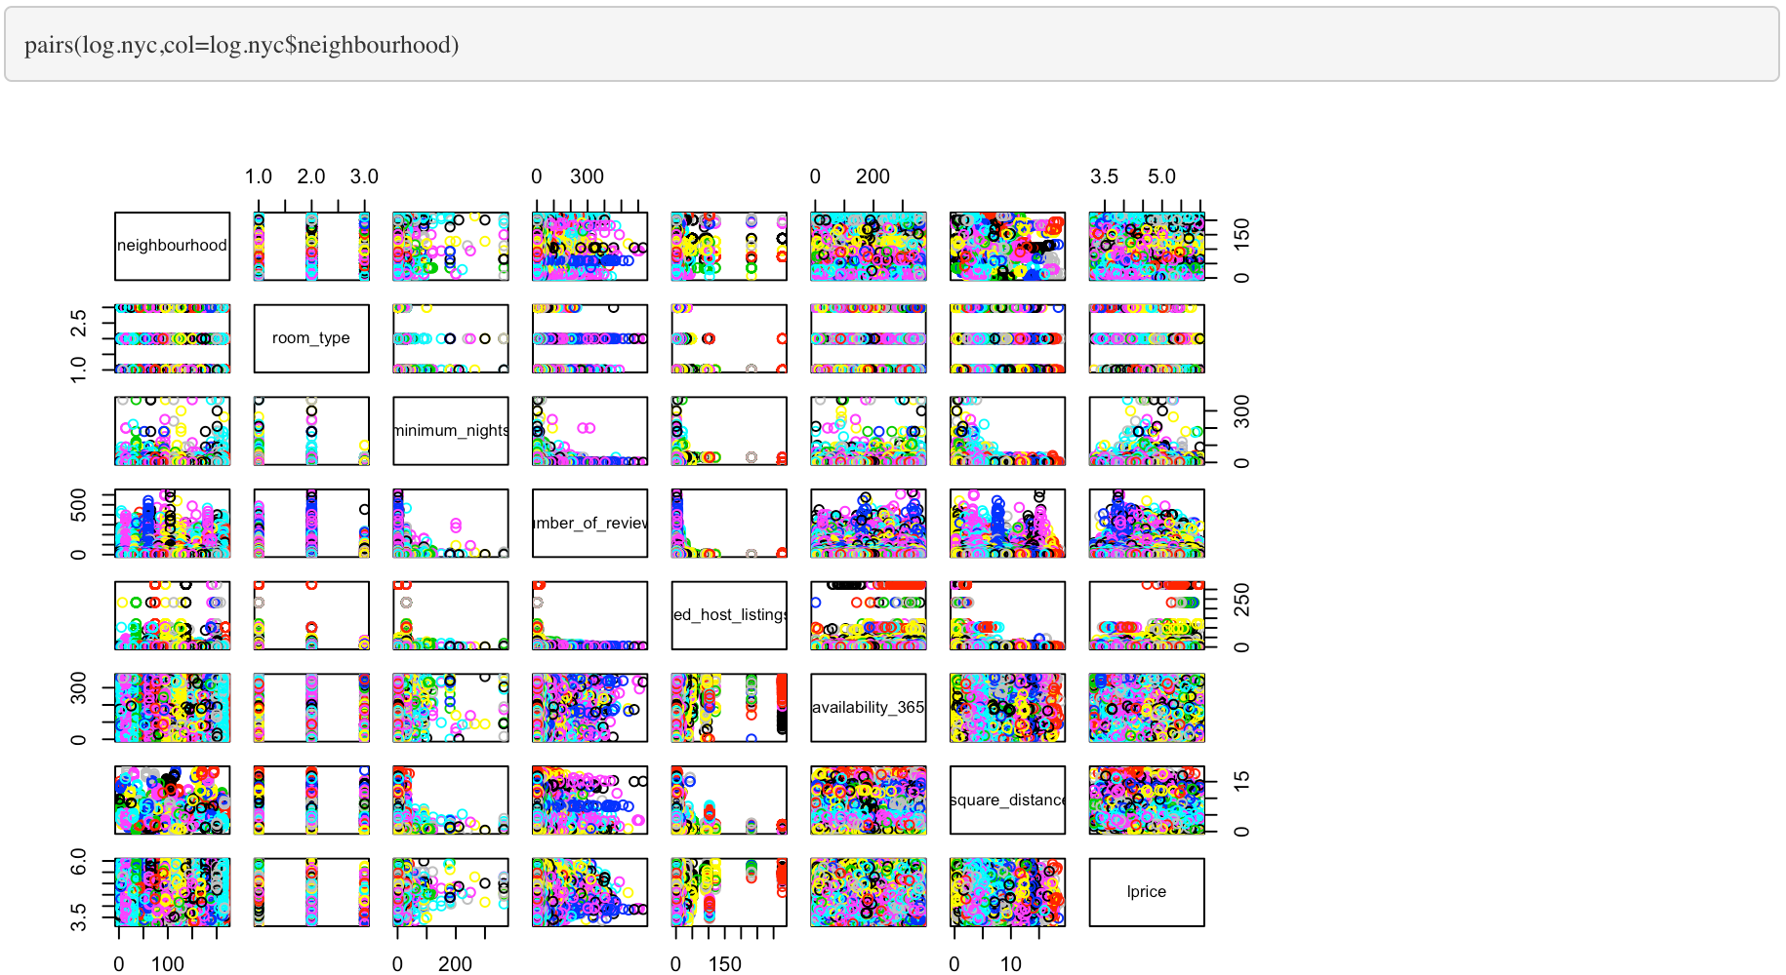 30

C. Figure 3 31

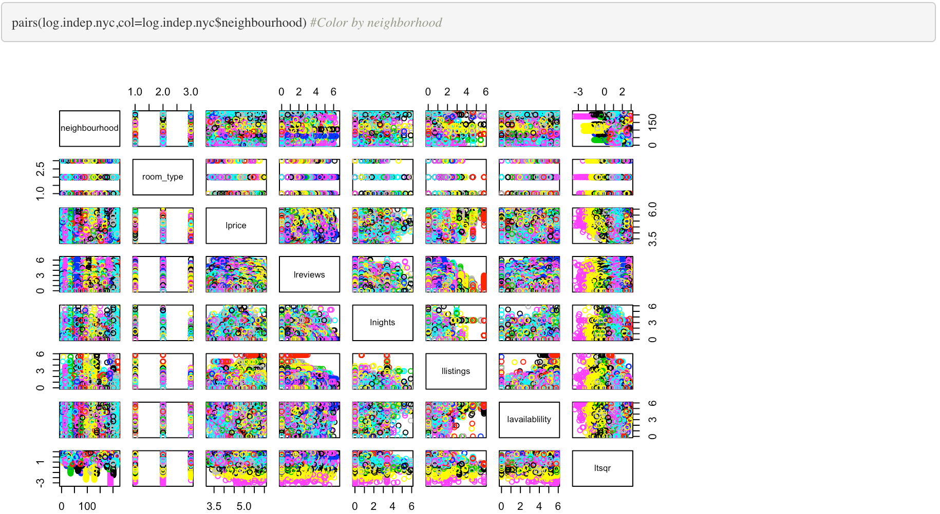 31

D. Figure 4 31

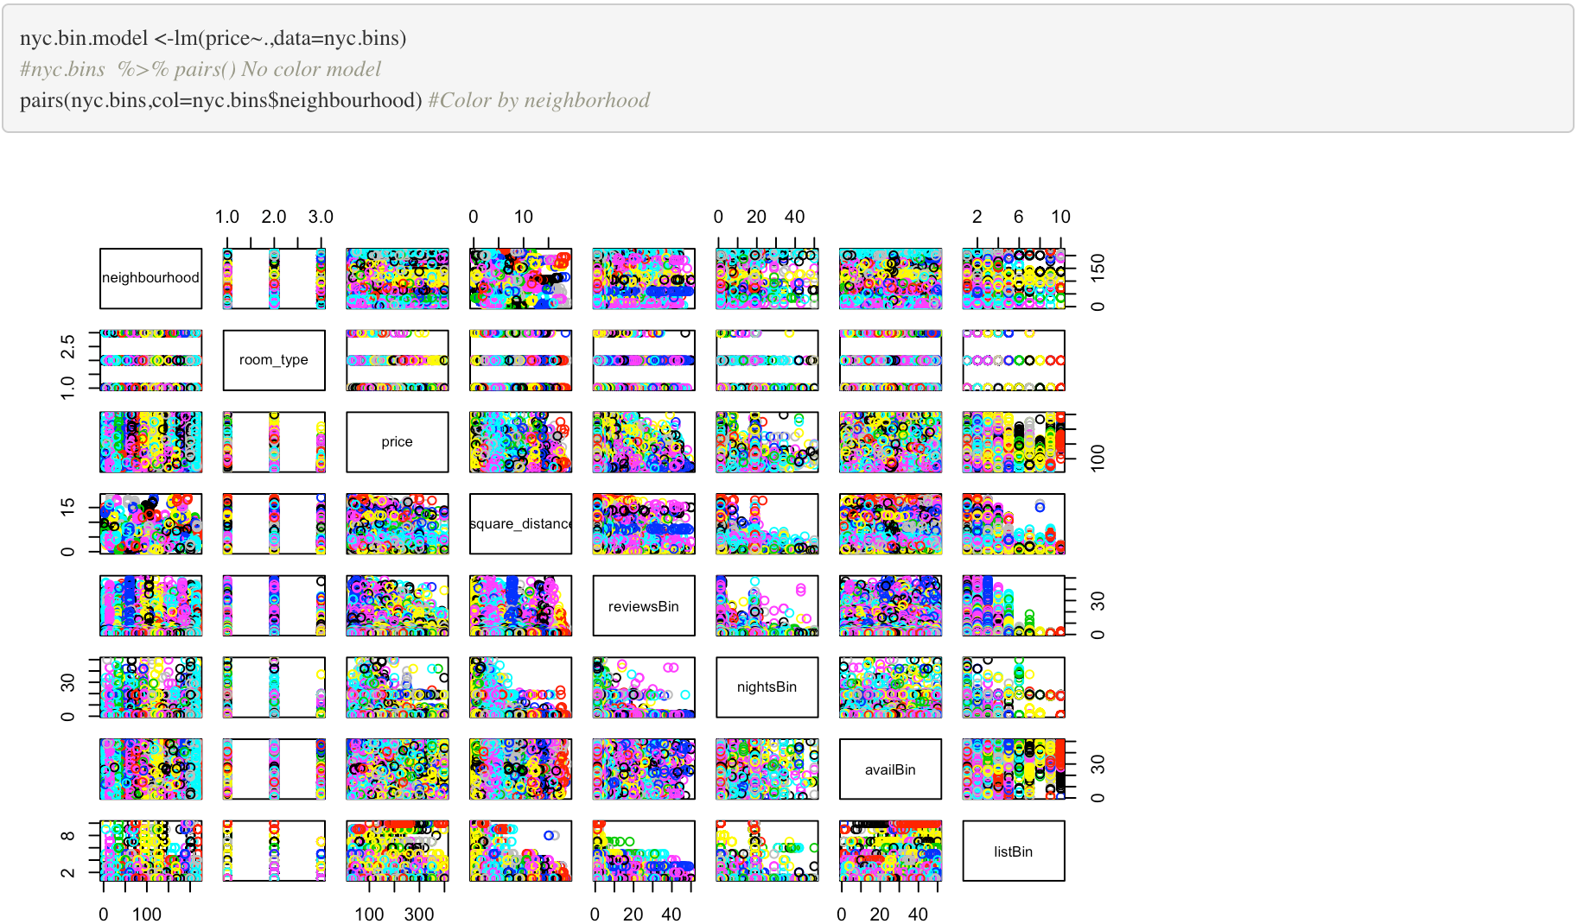 31

E. Figure 5 32

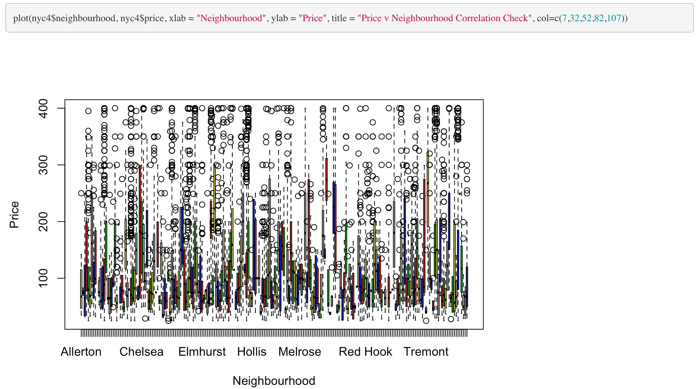 32

F. Figure 6 32

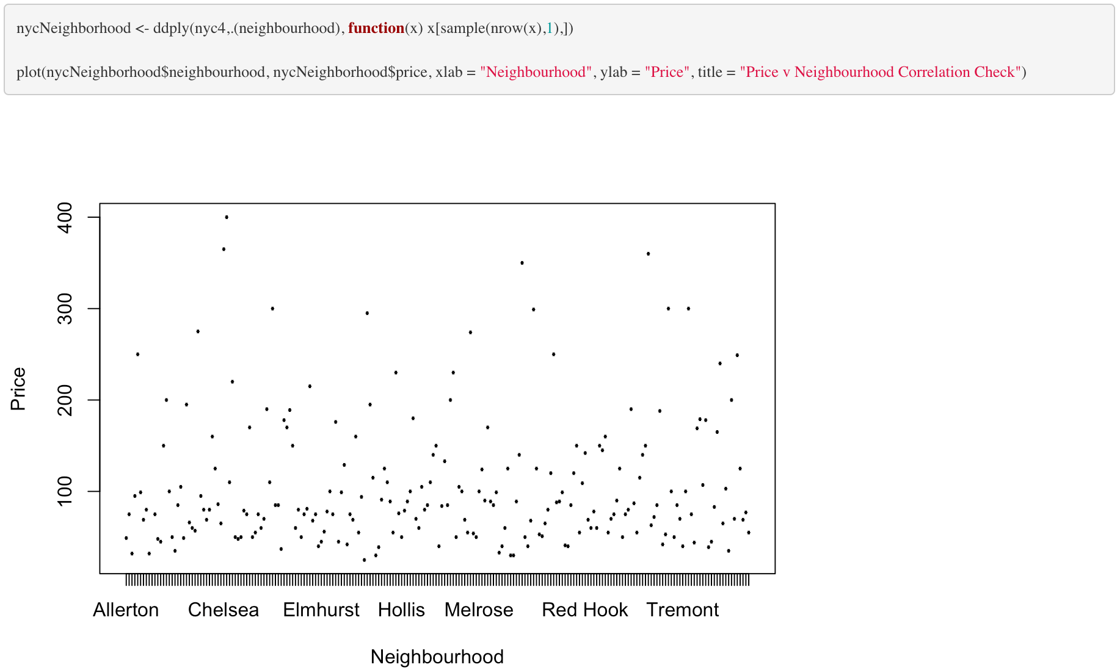 32

G. Figure 7 33

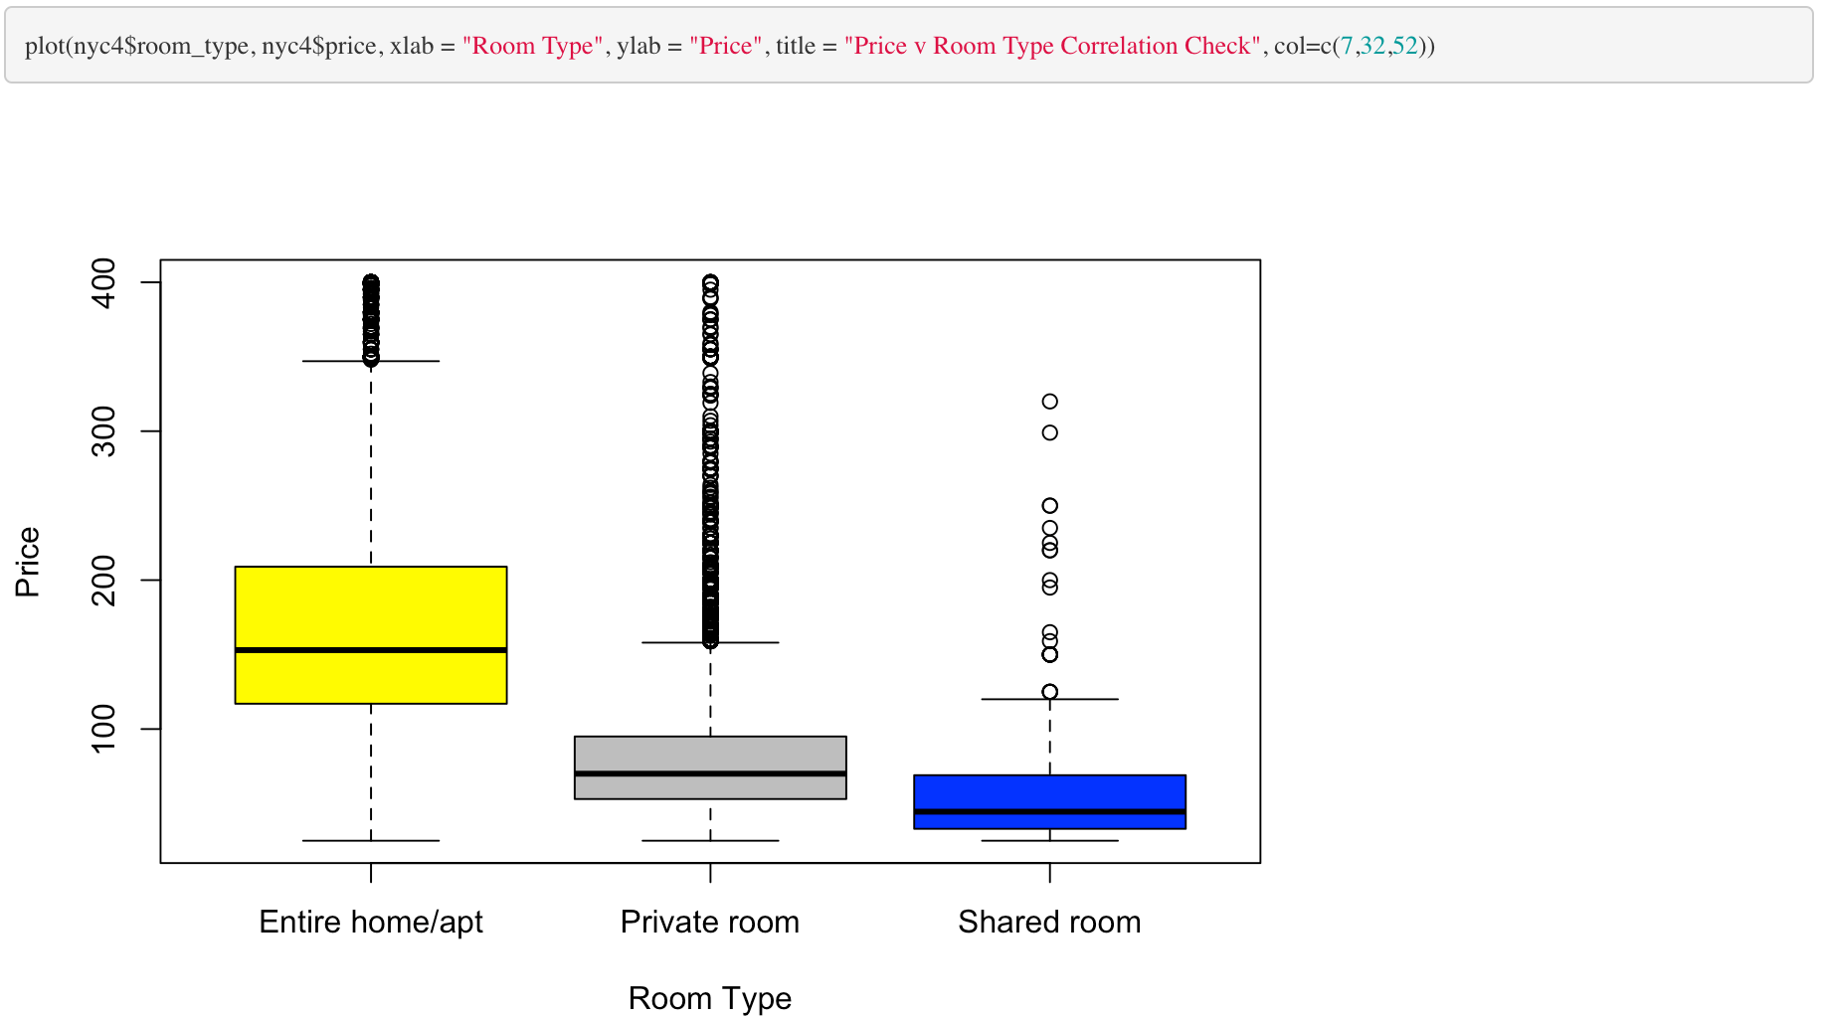 33

H. Figure 8 33

I. Figure 9 33

J. Figure 10 34

K. Figure 11 34

L. Figure 12 34

M. Figure 13 34

N. Figure 14 34

O. Figure 15 34

P. Figure 16 34

Q. Figure XX 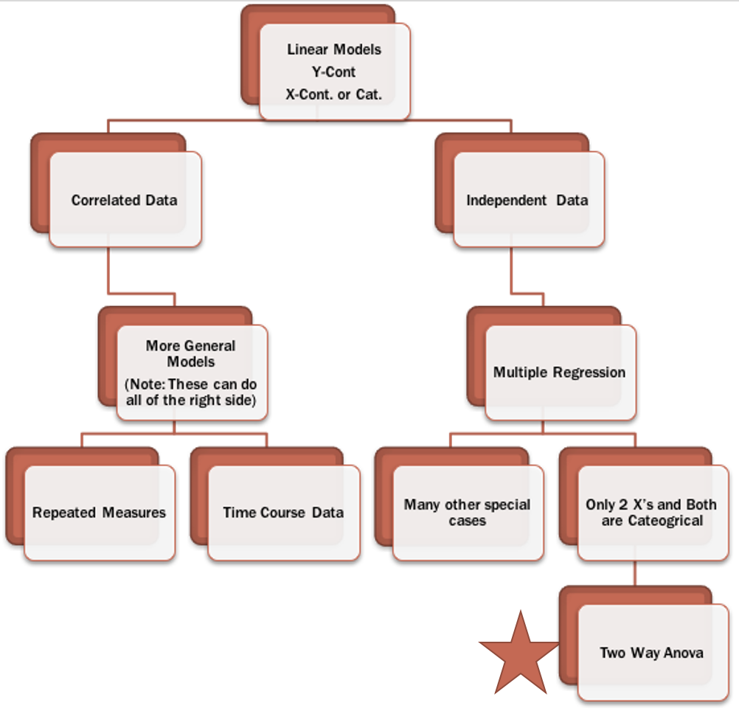 34

R. Figure XX 34

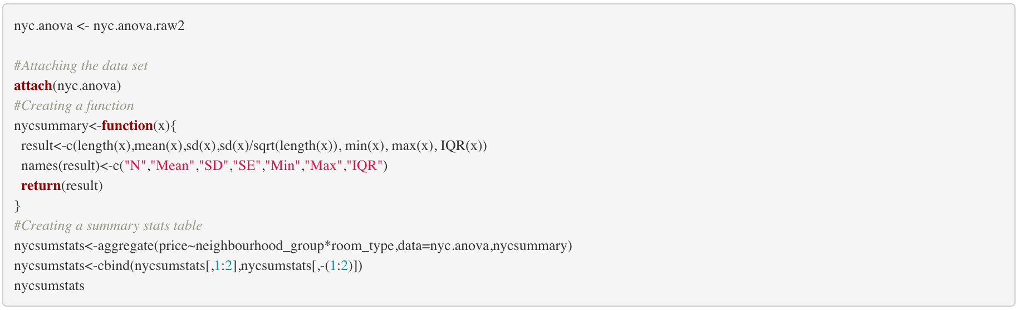 34

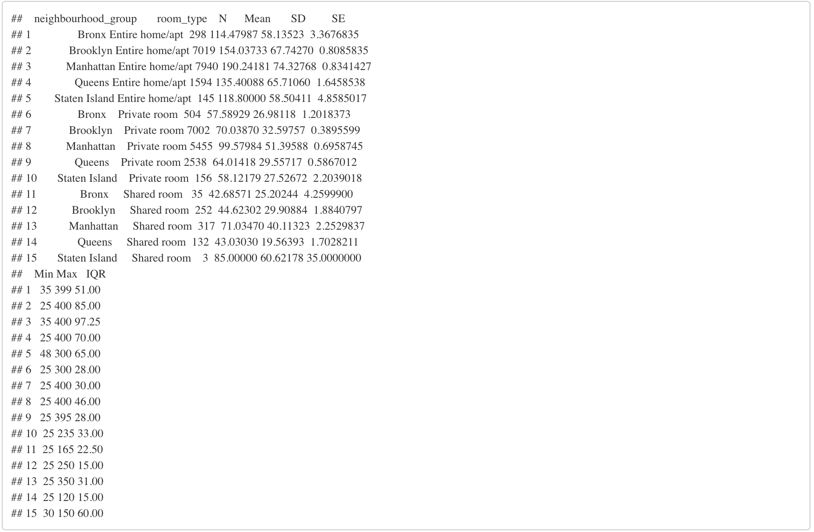 35

S. Figure XX 35

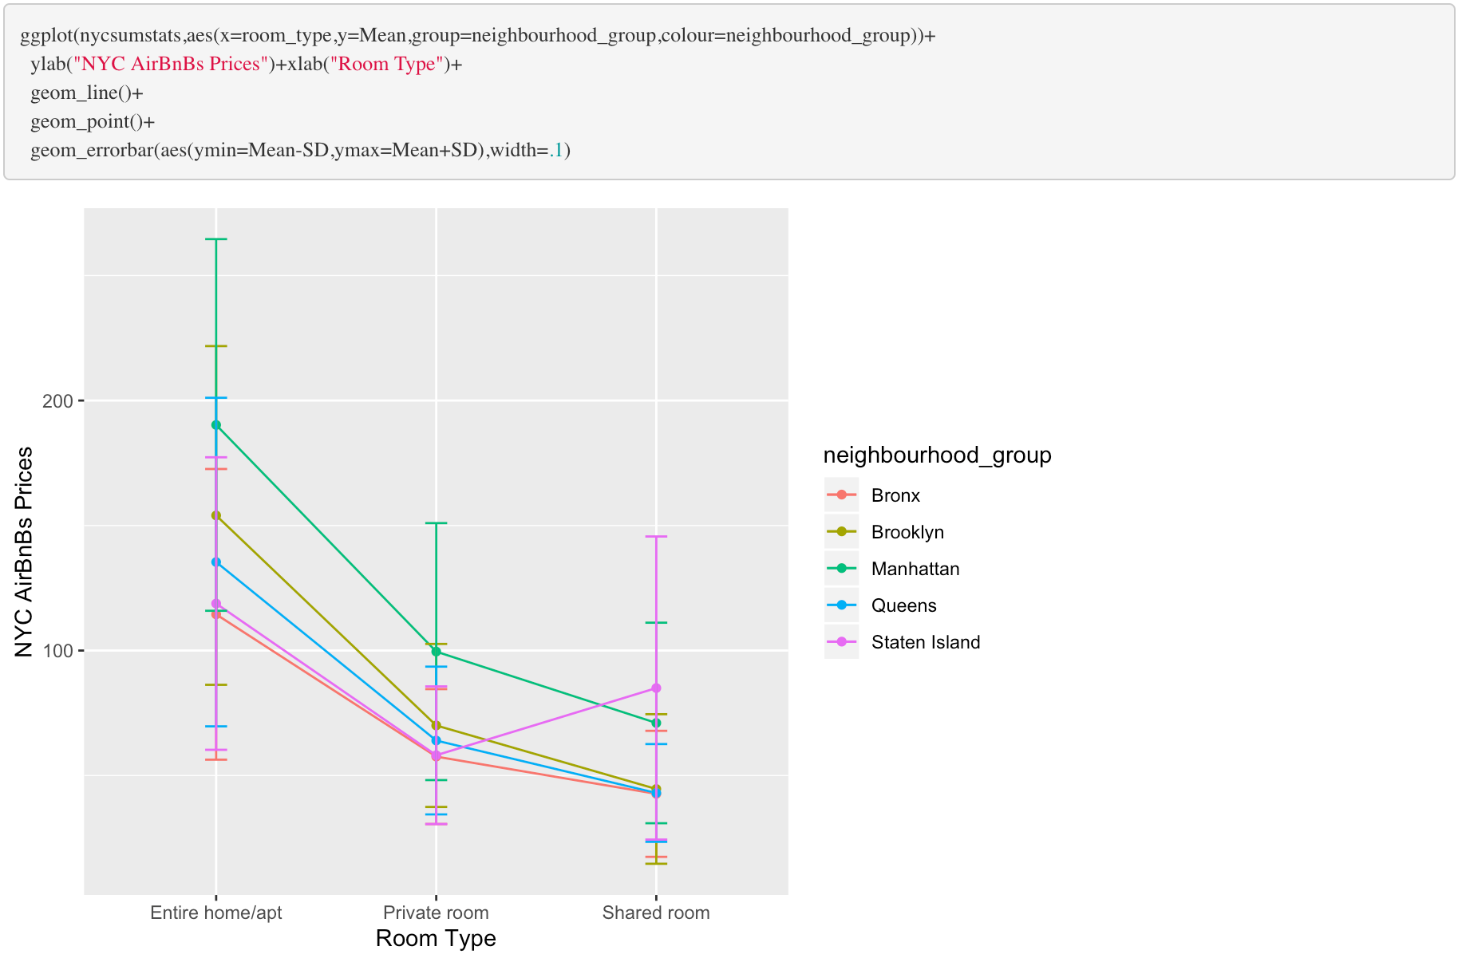 35

T. Figure XX 35

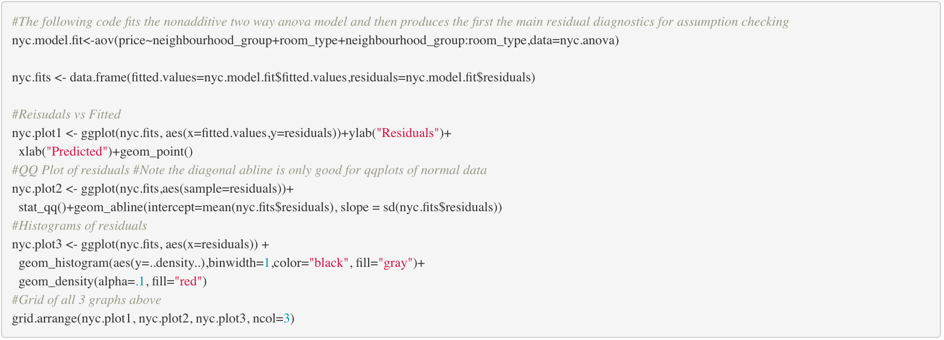 36

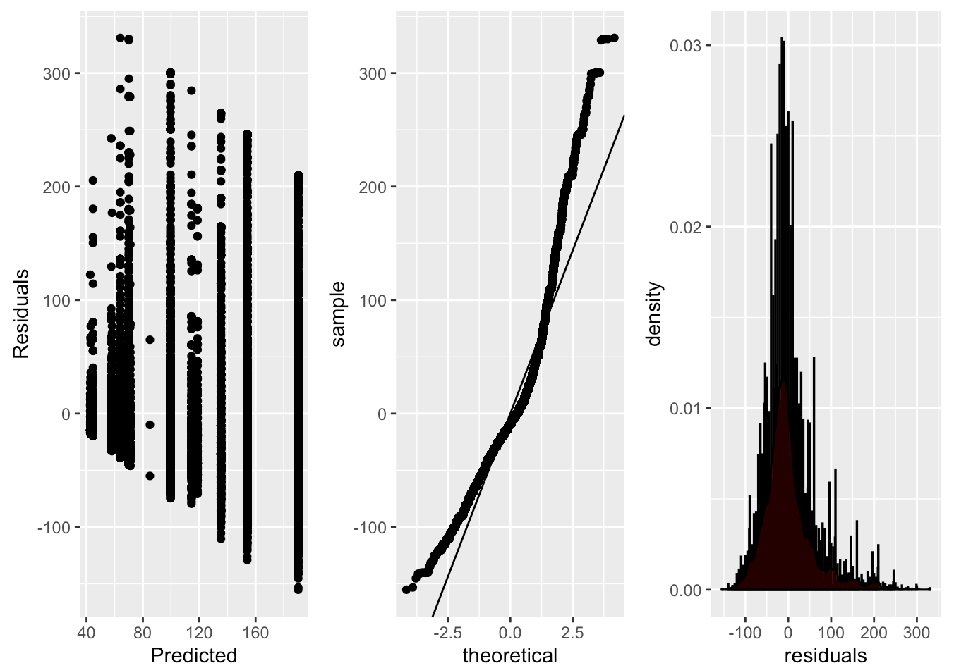 36

U. Figure XX 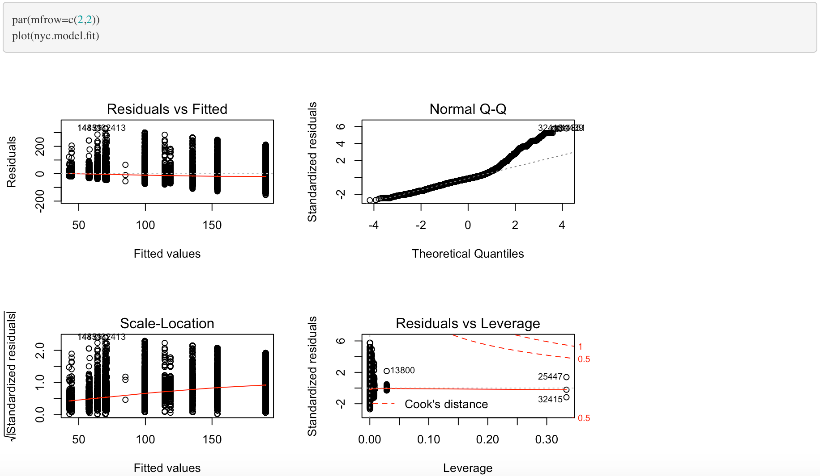 37

V. Figure XX 37

 37

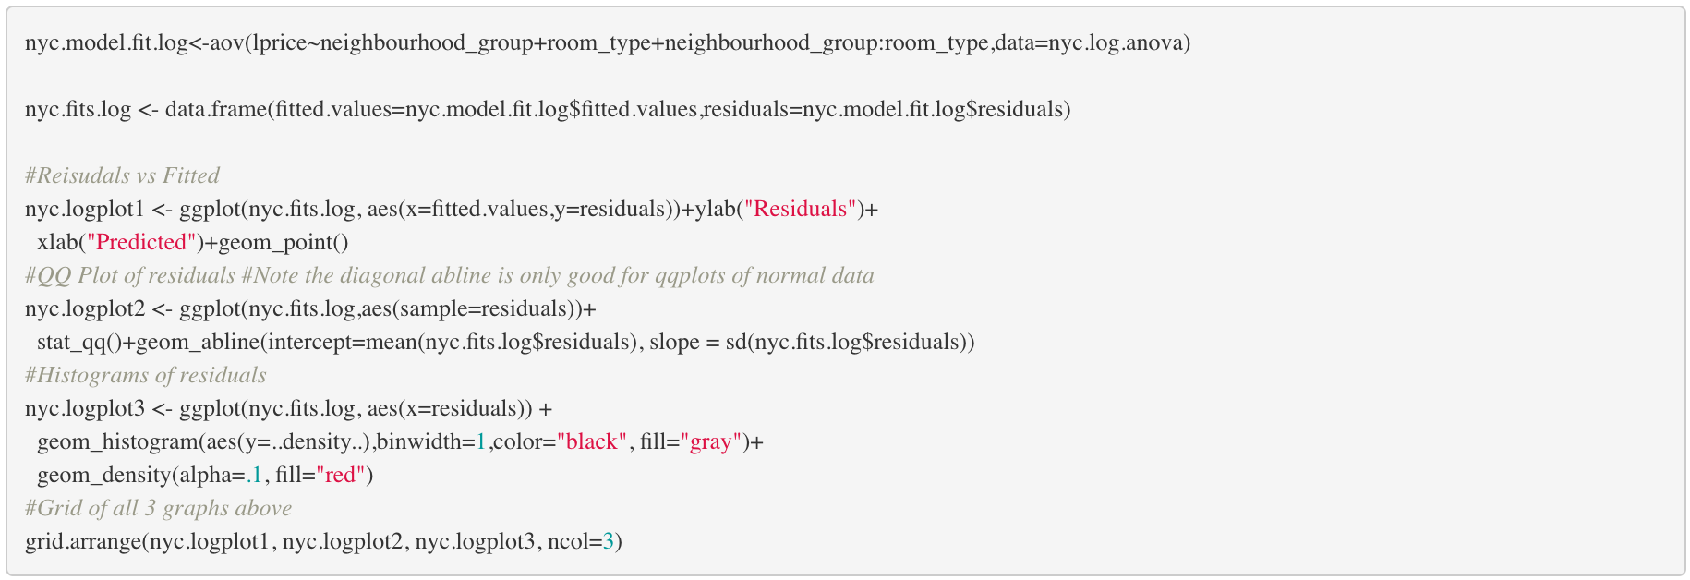 37

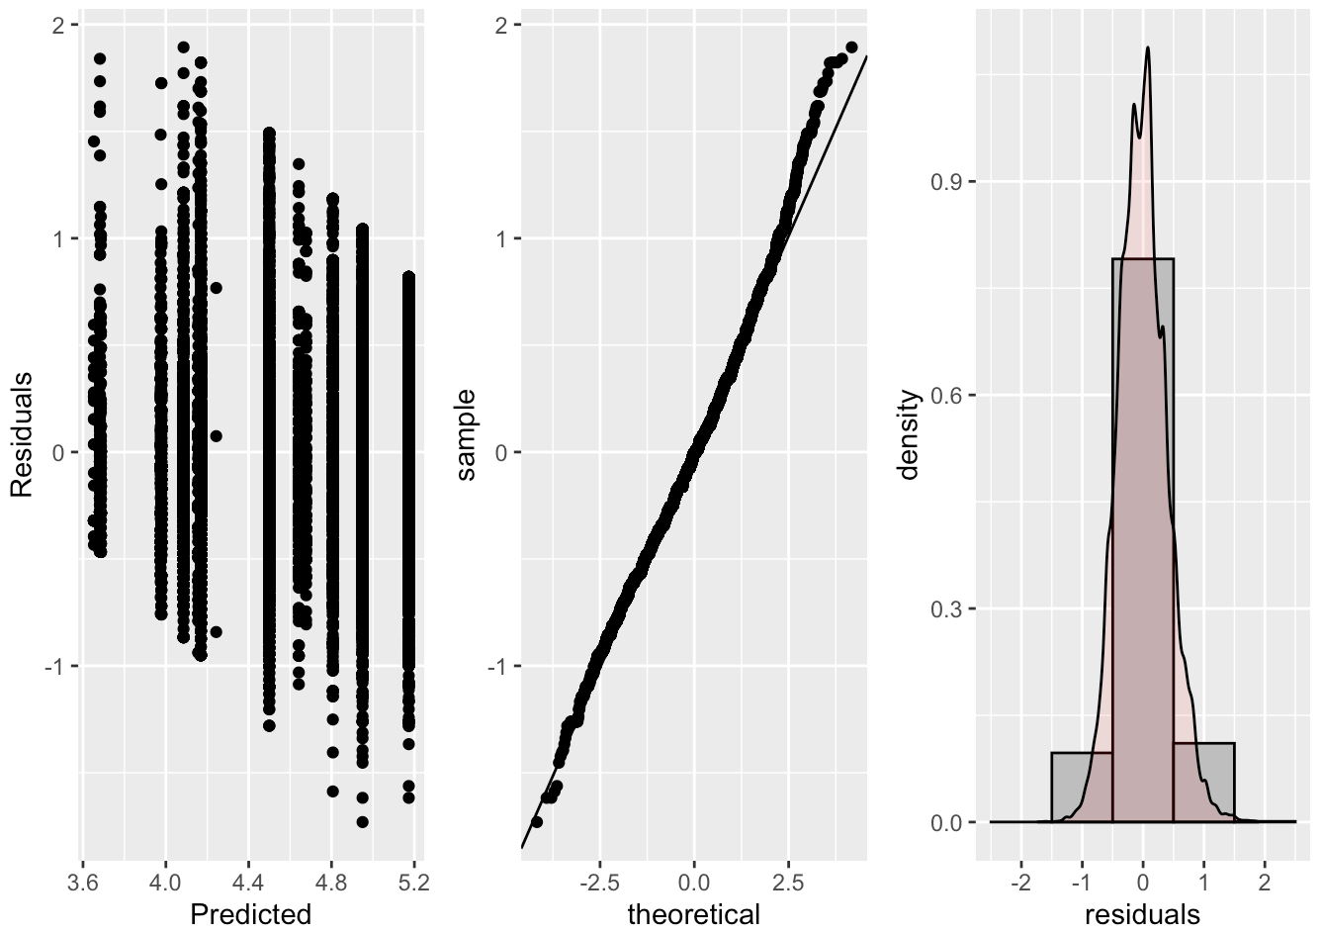 38

W. Figure XX 38

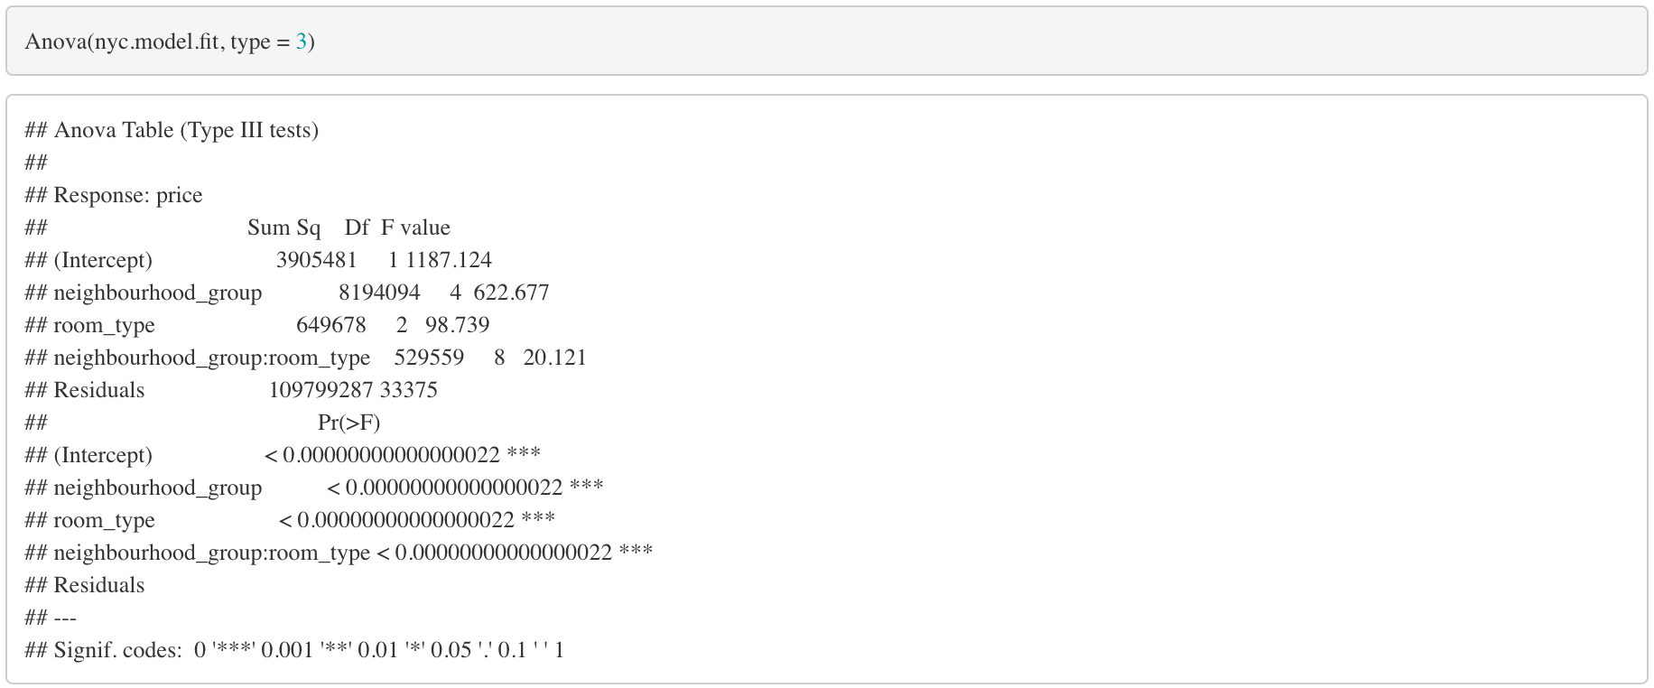 38

X. Figure XX 38

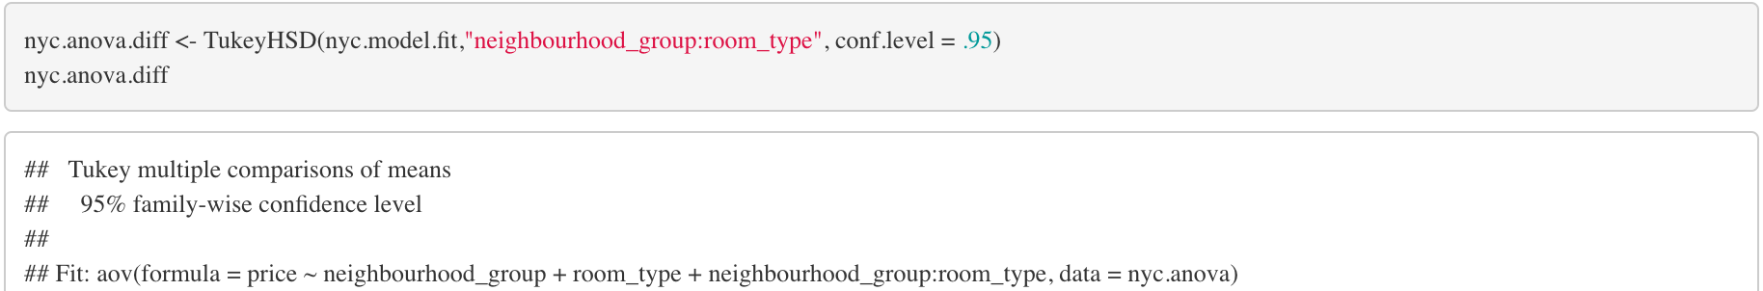 38

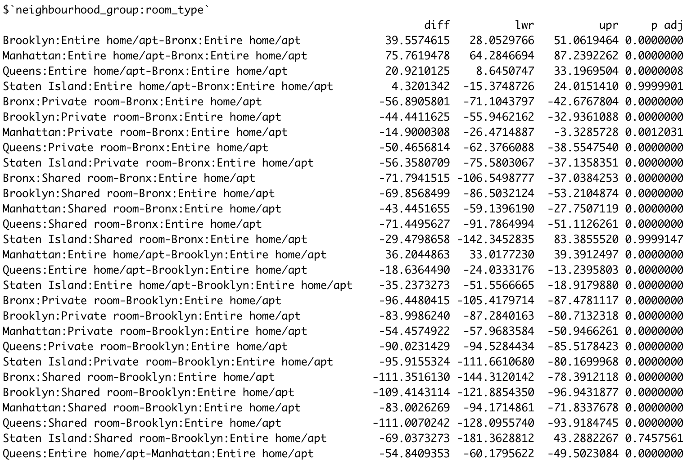 39

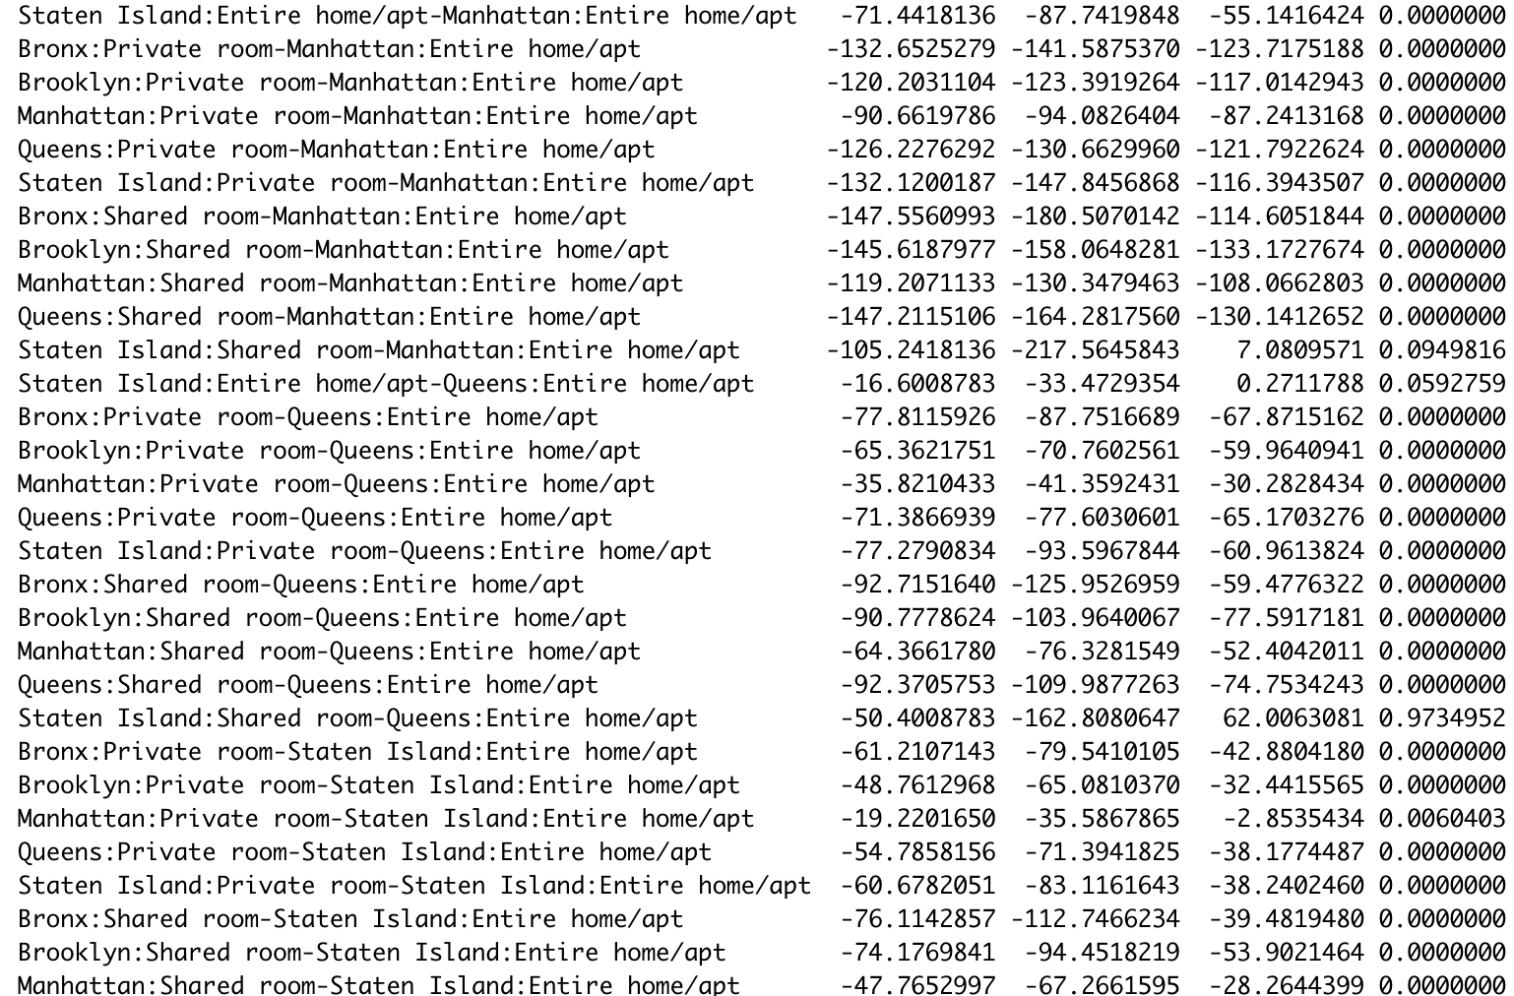 39

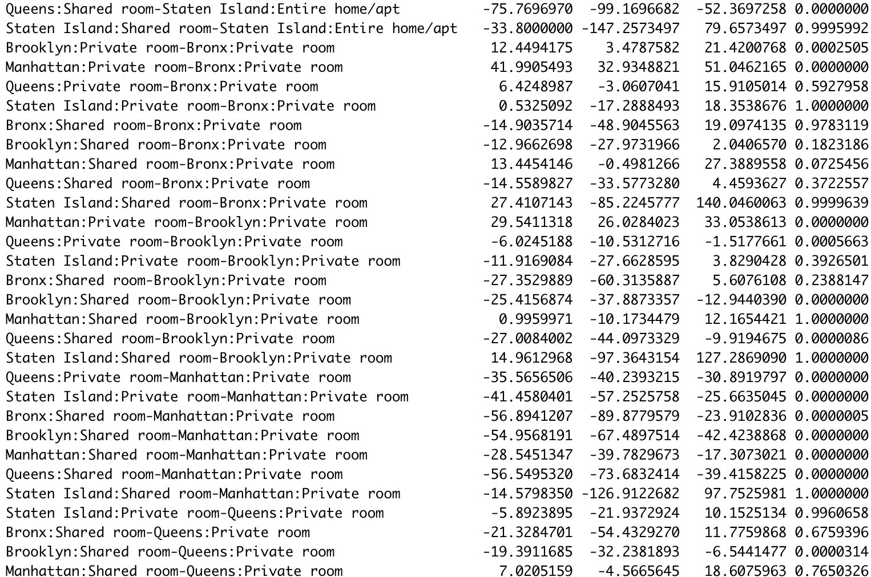 40

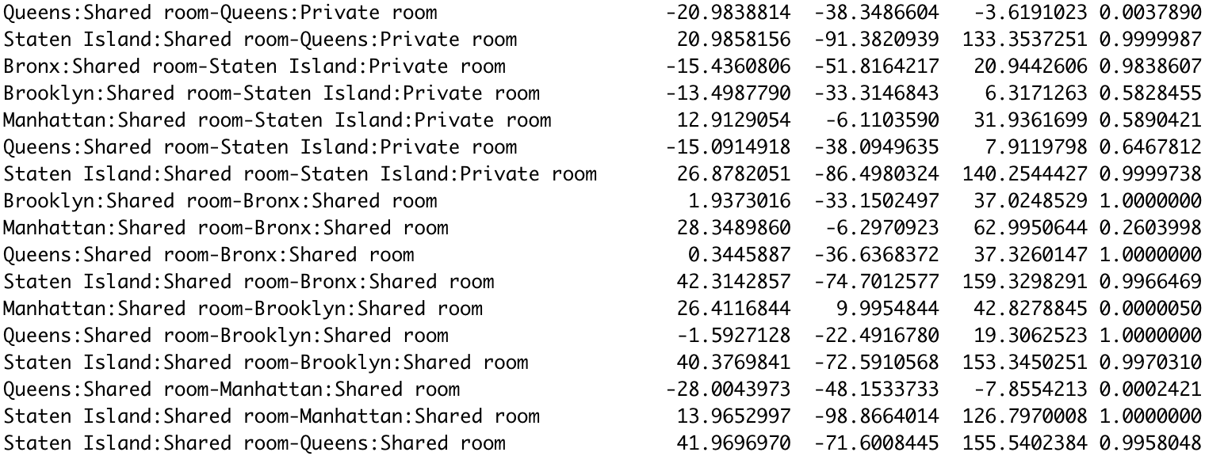 40

Y. Figure XX 41

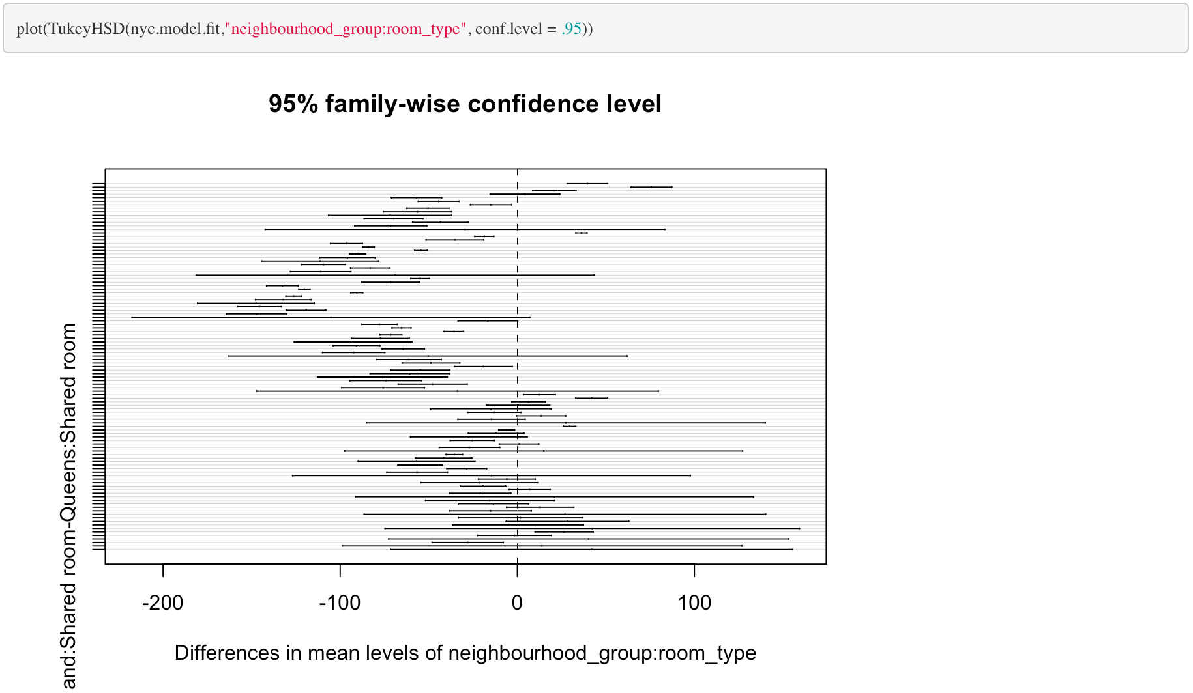 41

Z. Figure XX 41

AA. Figure XX 41

BB. X 41

CC. X 41

NYC Airbnb

# Introduction

## Who doesn’t love a vacation? I think it is safe to say, no one. In a recent [report by Eventbrite](http://eventbrite-s3.s3.amazonaws.com/marketing/Millennials_Research/Gen_PR_Final.pdf) “Millennials just can’t get enough. 72% say they’d like to increase their spending on experiences rather than on material things […], pointing to a move away from materialism and a growing appetite for real-life experiences.” We believe that the biggest thing people are looking to do is capitalize on cheap costs to stay places in order to have more money to spend on experiences while they visit their destination. Airbnb has captured this market.

## New York City is the city that never sleeps. The big apple. [Destination New Yorker](https://nycfuture.org/research/destination-new-york) has recorded the number of tourists tops around 60 million annually and hit a record high in 2017 with 62.8 million. With this being one of the top destinations in the world we focused our analysis on visiting this beautiful and eclectic destination.

## Contained within this report is an effort to predict the price of a traveler’s Airbnb when NYC is their destination. We utilize multiple linear regression techniques to try and fit the best model: intuitive, forward, backwards, seqreq, and LASSO selection methods. We complement these efforts with a two-way analysis of variance methodology and our findings explained for all of these models. This report is meant to provide our readers with a way to help predict their costs for staying in NYC Airbnb in order to help them leverage their vacation budget towards more experiences while they are there.

# Data description

## The data we used was provided by a Kaggle competition but originates from [Airbnb’s owned data](http://insideairbnb.com/). This data set in its raw state contains over 48,000 observations and 16 variables. Our dependent variable is *price* in US dollars for Airbnb’s available across the major NYC borrows. Please reference the below table for a full list of the variables and their description.

|  |  |
| --- | --- |
| **Variable Name** | **Variable Description** |
| id | Listing ID |
| name | Name of the listing |
| host_id | Host ID |
| host_name | Name of the host |
| neighbourhood_group | Location |
| neighbourhood | Area |
| latitude | Latitude coordinates |
| longitude | Longitude coordinates |
| room_type | Listing space type |
| price | Price in dollars |
| minimum_nights | Amount of nights minimum |
| number_of_reviews | Number of reviews |
| last_review | Latest review |
| reviews_per_month | Number of reviews per month |
| calculated_host­­_listings_count | Amount of listing per host |
| availability_365 | Number of days when listing is available for booking |

# Exploratory data analysis (EDA)

## Upon first look we reviewed the date columns. Since real estate in New York City is known for its high cost and constant fluctuation with growing and changing neighborhoods; we concluded that the most recent data would be the best in modeling something like the cost of renting real estate. We chose to leverage the *latest_review* variable and only build our model from listings that have reviews posted between 2017-2019.

## Next we decided to drop logically irrelevant variables. Things like unique identifiers (*id, host_name, host_id, name*) were the first we chose to remove. Unique identifiers like names and IDs would not be useful in predicting something like price. These are number and categorical labels that would only be considered white noise and if there is a correlation it would be at random and not have any practical significance in our model.

## With further review we had a unique thought on a variable we could create distance to time square. We were provided with the longitude and latitude of the different Airbnb listings. Since we are not creating a geographical analysis, we thought a good way to utilize these metrics was to create a new one called *tsquare_distance* to represent that Airbnb’s listing to Times Square, one of the most popular tourist destinations in NYC.

## Our next round of variables that were removed based on usability were: *last_review*, latitude, longitude, and *neighbourhood_group*. While the *last_review* variable was useful from filtering the data perspective, we did not see any practical significant to use this in our modeling since it does not come with any sort of sentiment indicator, which we do believe if something like review levels were: good, okay, and bad; that would affect the price of the Airbnb. Next, we chose to drop latitude and longitude. This is because, while positions of the Airbnb we do believe matter in price, a more accurate way to interpret this that will have practical meaning to our readers is through the names of the burrows (or *neighbourhood*). Then we dropped *neighborhood_group* this is because we found two variables that were measuring the same thing: *neighbourhood* and *neighbourhood_group*. We found the *neighbourhood* variable being the most granular variable and therefore potentially the most accurate.

## The next few steps in our EDA were to ensure things like a clean data set, outlier detection and multicollinearity. We did a ‘zero’ value check on variables where that does not make sense (e.g. any rows with 0 listed in *price* or *availability_365* were removed). Then we checked for NAs in our remaining data set. Where we found none. We also decided to target our model in order to only model those Airbnb listings that are between $25 - $400 USD. This is because we are looking to model some of the best deals for those individuals who are interested in their experiences once they arrive in NYC and not necessarily wanting to spend all their vacation dollars on the location where they store their luggage. Then we took a look at the *minimum_nights* variable, and removed anything over 365 days, thinking that a contract might be for a year but something that ranges in the ranges of thousands doesn’t make for our purposes.

## After producing a cleaned data set, we worked through non-linear trends using transformations. We initially check for linearity with our numeric variables against our dependent variable (*price*). We do not see any linearity (Figure 1). Note that all of the numeric variables show random clouds of data this indicating no real sign of a linear trend. Next we tried a log-linear transformation to see if we could surface one. Again, we’ve surfaced no direct linearity with the independent and depend variables (Figure 2) due to random clouds of data and in some cases, what appear to be a mountain like formations or ‘peaks’. Next in our attempt to surface linearity and performed a log-log transformation. In order to see that this has create an even stronger random cloud effect (Figure 3) and has not increased linearity, but in reality, has actually taken us farther away from creating an MLR relationship. In our last attempt to surface a plausible linearity with our numeric variables we have binned the data (Figure 4). Binning our continuous variables allows us to see if there is a large linear relationship from a high perspective by taking away the granularity in the data set, which can be helpful in a set as large as areas. Unfortunately, we are again met with random clouds of data and/or what appears to be ‘peaks’ in the data itself. After these exhaustive manipulations we are determining that this points us towards a more complicated relationship, likely not linear.

## NOTE: Within all of these linearity checks we included the graphical display by the *neighbourhood* in color. This was our check to see if even though there wasn’t a high linearity, we could derive any sort of borrow effect on the relationship, which would have been displayed by obvious groups. Unfortunately, these efforts also did not produce the ability to discern any type of relationship between the numeric variables and the independent numeric variables.

## Lastly, we checked for signs of linearity between our remaining two categorical variables and our dependent variable (*price*). We built boxplot graphs in order to investigate any differences in price based on the categories *neighbourhood* and *room_type*. In Figure 5 we can see that there are many borrows that are listed in our *neighbourhood* variable. While it is difficult to view, we can closely examine and see that there are multiple neighborhoods that seem to spike higher than others in our graph. In an attempt to confirm this, we are going to bin our neighborhoods to confirm our conclusion that there is a linear relationship to surface with this categorical variable and our dependent variable. In Figure 6 we can see that we were right, with varying levels in our point graph we are able to move forward with our conclusion of a significant linear relationship to surface between *neighbourhood* and *price*. In Figure 7 you can see that the room type greatly changes the price of an Airbnb. Therefore, it is likely we will surface a significant relationship in an MLR model. So, we will retain this variable as well.

## Our EDA complete we begin our model building for a multilinear regression.

# Objective 1: inuitive multilinear regression model

## Problem Statement

## XXXXXXXXXXXXXXXXX

## Model

### Linear Intuitive Model

## Comparing Models

## We worked on comparing different models using intuitiveness and multiple automatic selection methodologies offered through software packages such as: forward, backward, seqrep. We well as, LASSO. The strength of these different models can be seen below in our adjusted r2.

## The final model we went with is our intuitive model and you can follow the analysis below.

### Intuitive: Figure XX for code and model output in R

## Using automatic selection methods with the below models we chose to include interaction terms between all of the continuous independent variables. After logical reduction of variables in our EDA we were left with fewer variables then preferred when doing selection methods. With the addition of the interaction terms of the continuous independent variables then we are adding complexity to our models that would help with a better prediction.

### Log-Linear Intuitive Model: Figure XX for code and model output in R

### Forward: Figure XX for code and model output in R

### Backward: Figure XX for code and model output in R

### Seqrep: Figure XX for code and model output in R

## Based on our above adjusted r2 chart we can conclude that the strongest model is formed by our intuitive model. We acknowledge the adjusted r2 for our intuitive model may be larger than those others shown, however it is still not as strong as we would like. This again supports the possible conclusion that a multiple linear regression model may not be the best fit for our data.

### LASSO: Figure XX for code and model output in R

### Adj R2 Chart between tried models (Figure XX)

## Assumptions: Intuitive

### Residuals

### Constant Variance

### Independence

### Multicollinearity

### Outliers: Leverage / Cook’s D

## Cross Validation

## Interpretation: Intuitive Model

## Interpretation REQUIRED

## What variables could be collected and included in the future to make a better model? (Note from meeting with Turner)

## Confidence Intervals REQUIRED

## Additional Insights

## Multiple linear regression is just one option in building a predictive model for a continuous response. In our analysis we are see that a MLR analysis was likely not the best way to create our prediction model. We found it difficult to surface any linearity between the independent continuous variables and the dependent continuous variable. We saw shapes in Figure 1 through Figure 4 that likely demonstrate a more complex relationship than just linear. Any sort of extreme transformation actually results in the data moving farther away from linearity.

## Since we surfaced the above facts about out data and our data is large, we think that other methods such as Random Forest of K-NN would perform better. These options are less time consuming because the models’ complexity is built into software algorithms. We would also not have to specify how a relationship exists ahead of time, like we have for MLR.

## This being state we have seen a strong relationship between the borrow of the city as well as the room type being rented. This leads us into a Two-Way Analysis of Variance (ANOVA) model as it meets all the requirements to use this unique method (Figure 9). In our next section we explore what we surface with our Two-Way ANOVA.

## ~~Notes from meeting with Turner~~

## ~~Unit 2 slides – building blocks slide – add interactions slide~~

# Objective 2: two-way analysis of variance

## Problem Statement & Methodology

## We analyzed the ability to predict the prices of Airbnb listings in NYC based on the variables provided per unit by Airbnb. We completed a full exploratory data analysis (EDA) and took into account practicality of the information we determined the two best factors to determine the price were: *neighbourhood_group, and room_type* (reference code in Figure 10).

## Note: We chose to use *neighbourhood_group* instead of *neighbourbood* (used in MLR). This is due to the interaction’s significance and the ability to report back that information in a digestible way.

## Analysis

### Two Factor, Two-Way Analysis of Variance (ANOVA)

### With our two-way ANOVA, we were in a two independent categorical variables scenario. With our cleaned data we created a summary containing: *mean, standard deviation, standard error, minimum, maximum, and inner quartile range* of our dependent variable: *price* (reference code in Figure 10).

### Mean Profile Plotting

### Once this was completed, we used the table to create a mean profile plot (Figure 11). We determined our Two-Way ANOVA was displaying nonadditive model characteristics; in other words, our graph, Figure 11, indicated that the changes in the mean price of an Airbnb in a specific neighborhood depends on what type of room you are renting.

### Our data set had an unequal number of observations between groups in the independent variable: *room_type*, this means our data is unbalanced. Therefore, the means plot we have displayed is using the standard deviation instead of our standard errors from the summary table. This is because the plot using standard deviations allows us to gain better insight into the assumptions of equal variance. This is because the standard error is not a measure of variability of the data itself.

### Diagnostics

### With the above results we can fit a full nonadditive model (Figure XX). Overall, we can see the residual show close to an even distribution, Figure XX (left graph). We identified a near random cloud of residuals around the 0 x-axis. There is a slight unevenness in the difference of distribution, however we move forward with the assumption met as this is close to normality and while a logged transformation may bring it closer to a random cloud, it is also not perfect (Figure XX). Allowing to the model to stay in a linear and unlogged format makes for practical interpretation and analysis.

### There is a small concern for the violation of normality. In Figure 12 (right graph), we can see that the data is slightly skewed right. There is tail reaching to the right side of the histogram, however the majority of the data is distributed around zero. In reviewing this further we can see the same results in our QQ plot, Figure 12 (middle graph), while we would prefer a perfectly straight line, this is close with only a we would expect to see this as close to a straight line as possible. We moved forward with the assumption passed after invoking the Central Limit Theorem due to the large sample size and move forward with this slight departure from normality.

### There are no extreme outliers present in our Cooks D / Leverage graph (Figure XX). All of the points on the far right still fall below our dashed line and also fall well below our level of leverage of 1.

### Lastly, to address the independence assumption, it is important to note that New York City is a place of expensive real estate. The borrows (neighborhoods) contained within the city contribute to how expensive real estate may or may not be. This would in sense, seem to violate our assumption of independence, since we are saying the neighborhood a house is in would often determine the price and therefore likely the rental price. But since all real estate is going to be dependent on the real estate around it, all modeling for pricing would have to have assumed independence Therefore, we move forward cautiously with the assumption of independence met.

### Testing

### For our testing we performed a high-level ANOVA that tested to see if the individual metrics, as well as their interaction show a significant p-value at the 0.05 alpha level. To do this we completed a Type-III Sums of Squares F-test; our results show that both our independent metrics *neighbourhood_group,* *room_type*, as well as our interaction between them *neighbourhood_group* room_type* are overwhelmingly statistically significant at the alpha 0.05 level. The F-values and p-values are: [622.677, <.0001]; [98.739, <.0001], and [20.121, <.0001] respectively (Figure XX). Since the interaction term is significant at the 0.05 alpha level, we have confirmed our assumption that this model is nonadditive and reject our H0, determining solidifying that the neighbourhood depends on room type (and vice versa) when it comes to predicting price of an Airbnb in NYC.

### Since our interactions have proven significant, we moved forward with Tukey-Kramer (since all assumptions have been met in our model) pairwise comparisons of every variation of the *neighbourhood_group* and *room_type* variables paired. This will tell us which pairs of the *neighbourhood_group* and*,* *room_type* are significant since the Type III SS test only tells us that they are significant in general.

### Examining the adjusted p-values and confidence intervals, there are multiple comparisons that yields overwhelmingly statistically significant results with p-values < 0.05 alpha level (at a 95% confidence level). These comparisons can be found in Figure 16. There are so many groups we recommend referencing the plot found in Figure 17, any confidence internal shown that does not cross the zero threshold is showing a statistically significant p-value at the 0.05 alpha level. All non-significant pairs have been called out in Figure 18.

## Interpretation

## When we ask ourselves how much something is going to cost, we often research those similar items on our own to have an educated guess on the amount of money we are going to spend. We have done just this with our two-way ANOVA for NYC Airbnb customers. In this analysis we used two categorical variables to predict the dependent variable: price of an Airbnb in NYC based on neighborhood and type of rental. Our immediate conclusions tell us yes, with over whelming statistical evidence, the price of your Airbnb will be determined by neighborhood and the type of rental you choose. Out of 105 comparisons 69 were deemed statistically significant in our pairwise comparison of the different neighborhoods and room types with p-values <= 0.01 which is less than the alpha level of 0.05 (Figure 17).

## Differently stated, the practical significant in taking into account the borrow and room type you rent will highly affect the amount of money you spend on your Airbnb in NYC. For example, in Figure XX we have ordered the difference in price mean from lowest to highest. This is showing us that the difference in money you can save by renting a shared room in the Bronx as compared to an entire home/apt in Manhattan can be upwards of 147.56 dollars a night! This is huge saving when you want to spend more money on your experiences and not where you might be storing your luggage for a trip. Overall, you can see that any shared room in a neighborhood other than Manhattan is showing us a great saving in dollars spent. I would note that if a shared room is something you can handle; this is how you would save the most money when renting and Airbnb in NYC. Secondly, you can see that shared and private rooms in any neighborhood other than Manhattan are showing a significant difference in mean price of the Airbnb. This means that in general, if you want to save money while staying at an Airbnb in NYC, you might want to consider staying outside of the city center and commuting into Manhattan for all your tourist needs.

### ~~Notes from meeting with Turner~~

### ~~There’s so much sample size that everything is significant.~~

### ~~**Practical Significance~~

#### ~~Back transform the differences~~

#### ~~Take the table of difference out and rank from highest difference to lowest different and talk about the highest and cut it off for practical significance of the information~~

#### ~~Look at the differences for the different neighborhoods, if they are all the same then the practical importance of the information~~

#### ~~Another way to tackle this would be to make the call would be to base off the graph, summary stats, and comparison are the same then we could conclude this is falling more like an additive model. Move forward with an additive model to simplify the results and interpretation.~~

#### ~~Interpret a single or cherry pick one and explain how to understand it, then address/highlight the top differences and talk about their practical significance as a whole~~

#### ~~***Students tend to not do enough EDA, show graph how to illustrate those relationships~~

#### ~~***Not enough talking, the graphs/tables do not tell the story. But you do, exhibit you know what you are doing~~

# Appendix

## Figure 1

## Figure 2

## Figure 3

## Figure 4

## Figure 5

## Figure 6

## Figure 7

## Figure 8

## Figure 9

## Figure 10

## Figure 11

## Figure 12

## Figure 13

## Figure 14

## Figure 15

## Figure 16

## Figure XX

## Figure XX

## Figure XX

## Figure XX

## Figure XX

## Figure XX

## Figure XX

## Figure XX

## Figure XX

## X

## X